

**CALVIN (Python Version)**

**Fall 2018 Shortcourse**

Prepared by

Mustafa S. Dogan

[msdogan@ucdavis.edu](mailto:msdogan@ucdavis.edu)

Center for Watershed Sciences

Date: October 5, 2018

Location: Center for Watershed Sciences Conference Room

**Date:** Friday, October 5, 2018

**Location:** UC Davis, [Center for Watershed Sciences](https://goo.gl/maps/PKFjuVNEJiF2) Conference Room

**Registration:** <https://goo.gl/forms/6nUVGddb8xhUOSVn1>

**Shortcourse GitHub Repo:** <https://github.com/msdogan/CALVIN-shortcourse>

# Tentative Agenda and Topics

|  |  |  |
| --- | --- | --- |
| 10.00 – 10:05 am | - | Introduction |
| 10:05 – 10:30 am | - | Set-up required software |
| 10:30 – 11:15 am | - | CALVIN Theory |
| 11:15 – 12:00 pm | - | HOBBES overview and exporting network data |
| **12:00 – 01:00 pm** | **-** | **Lunch break** |
| 01:00 – 01:15 pm | - | CALVIN Python version updates and Pyomo |
| 01:15 – 02:15 pm | - | “Abstract model”: run and analyses |
| 02:15 – 03:15 pm | - | “Concrete model”: run and analyses |
| **03:15 – 03:30 pm** | **-** | **Break** |
| 03:30 – 04:30 pm | - | Postprocessing and analyzing results |

# Summary

This shortcourse is intended for those who are interested in California’s water supply system and large-scale water optimization modeling. Mechanics of the CALVIN model will be covered. This crash course introduces open-source CALVIN version modeled in Python-based Pyomo environment, employing faster solvers and giving an opportunity for better representation of the system. It walks through steps for required software installation process for the CALVIN model, as well as creating a model run and postprocessing results.

Recommended readings

* **Original publication of CALVIN** (Draper et al., 2003):

Draper, A. J., Jenkins, M. W., Kirby, K. W., Lund, J. R., & Howitt, R. E. (2003). Economic-Engineering Optimization for California Water Management. *Journal of Water Resources Planning and Management*, *129*(3), 155–164. <https://doi.org/10.1061/(ASCE)0733-9496(2003)129:3(155)>

* **Open-source Python version of CALVIN** (Dogan et al., 2018):

Dogan, M. S., Fefer, M. A., Herman, J. D., Hart, Q. J., Merz, J. R., Medellín-Azuara, J., & Lund, J. R. (2018). An open-source Python implementation of California’s hydroeconomic optimization model. *Environmental Modelling & Software*, *108*, 8–13. <https://doi.org/10.1016/j.envsoft.2018.07.002>

Table of Contents

Tentative Agenda and Topics 2

Summary 3

Required Software 5

GitHub account 5

Cloning or downloading required GitHub repositories 5

Installing CALVIN network tools to export input data 6

Instructions for Mac OS 7

Installing Python and other libraries via Anaconda package 8

Installing Pyomo and its solver 8

Mac OS Pyomo and solver installation 9

Windows Pyomo and solver installation 9

# Required Software

Several different installations are required in order to export network data from HOBBES, and then create and run CALVIN model. CALVIN is an open-source project, so all installations are free of charge! CALVIN can connect to commercial solvers, some of which are free for academic purposes, but there we will use open-source solvers for the purposes of this shortcourse. Required installations are cross-platform, so they (should) run on Windows or Mac OS.

## GitHub account

Model data and components are hosted in GitHub, a web-based data and code hosting service with version control. So, having a GitHub account and downloading GitHub desktop is strongly recommended but files can be downloaded from hosted repositories as zip files without an account.

* Sign up for a GitHub account: <https://github.com/>
* Download GitHub desktop: <https://desktop.github.com>

|  |  |
| --- | --- |
| ../../../../Desktop/Screen%20Shot%202018-08-08%20at%2010.41.25%2 | ../../../../Desktop/Screen%20Shot%202018-08-08%20at%2010.43.21%2 |

*Figure 1. GitHub sign-up page and desktop*

## Cloning or downloading required GitHub repositories

After signing up and installing GitHub desktop, go to each of these following repositories and clone them, or if you can download as zip file as shown below. Please read “Readme” files by scrolling down in each repository. Required repositories:

* <https://github.com/ucd-cws/calvin-network-data>
* <https://github.com/ucd-cws/calvin-network-tools>
* <https://github.com/ucd-cws/calvin>

Bonus

* <https://github.com/msdogan/CALVIN-shortcourse>

Cloning steps (repeat this for each repository):

1. Go to repository link (above)
2. Click on green “Clone or download” button.
3. “Open in Desktop” or if you do not have account or GitHub desktop, click on “Download ZIP”

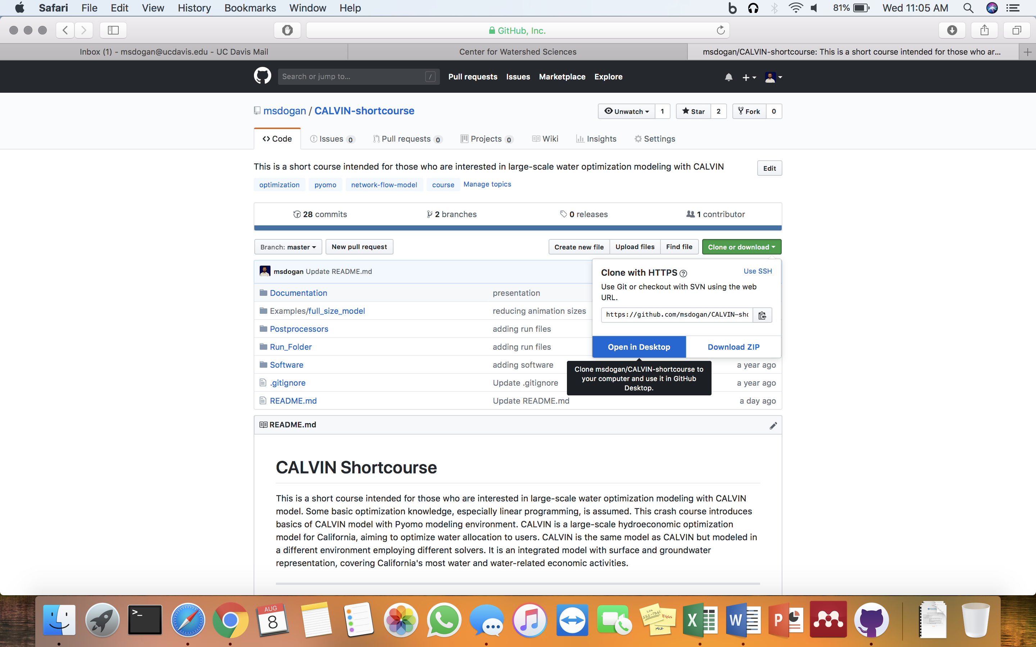

*Figure 2. Cloning a repository*

## Installing CALVIN network tools to export input data

We will use command line to install required software (Node.js) and export network. Instructions on how to use command line for Windows and Mac OS are provided. CALVIN network tools (<https://github.com/ucd-cws/calvin-network-tools)> has several feature, such as exporting network, running HEC-PRM (old solver), updating database with a new run. However, we will only use matrix feature, which exports water network as a matrix. This matrix is used as input for Pyomo model.

### Instructions for Mac OS

**Step 1:** Download and install Node.js from <https://nodejs.org/en/>

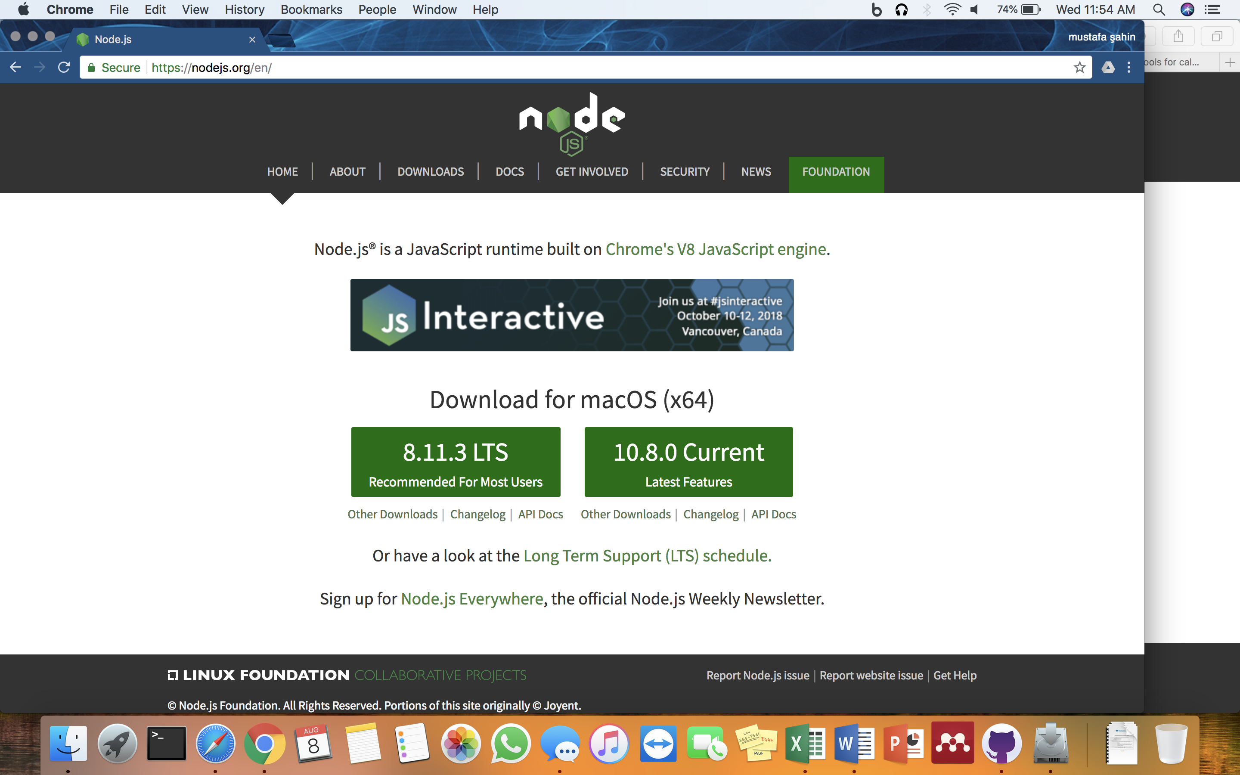

*Figure 3. Node.js installation page*

**Step 2:** Open Terminal and run following command to install calvin-network-tools via npm. If you do not know how to open Terminal on your Mac, just google it.

Type this command and hit enter.

npm install -g calvin-network-tools

if you get a permission error, try sudo running and enter your Admin password:

sudo npm install -g calvin-network-tools

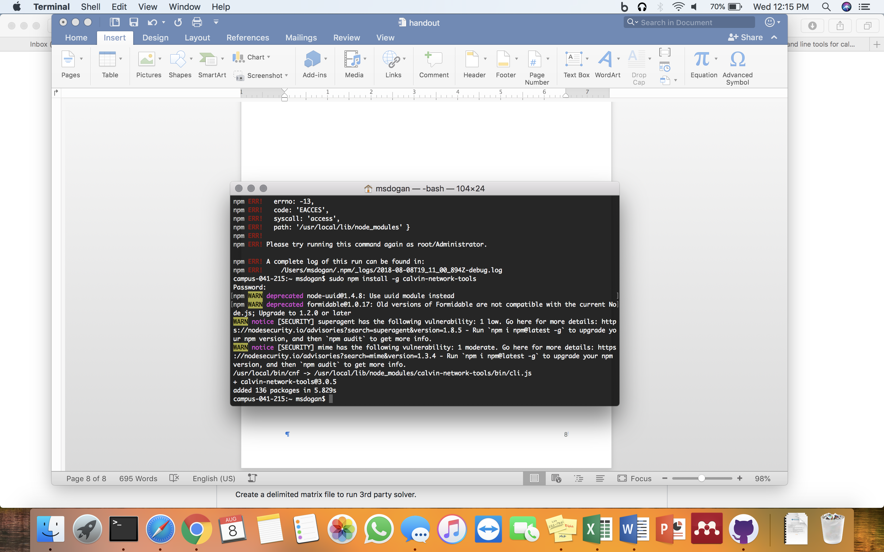

*Figure 4. Installing calvin-network-tools via npm on Mac Terminal*

**Step 3:** Specify data location. Data is calvin-network-data cloned or downloaded from its repository. Run following command and enter path to data file when prompted. Path is folder location where you cloned calvin-network-data. Example: /Users/msdogan/Documents/github/calvin-network-data

sudo cnf library init

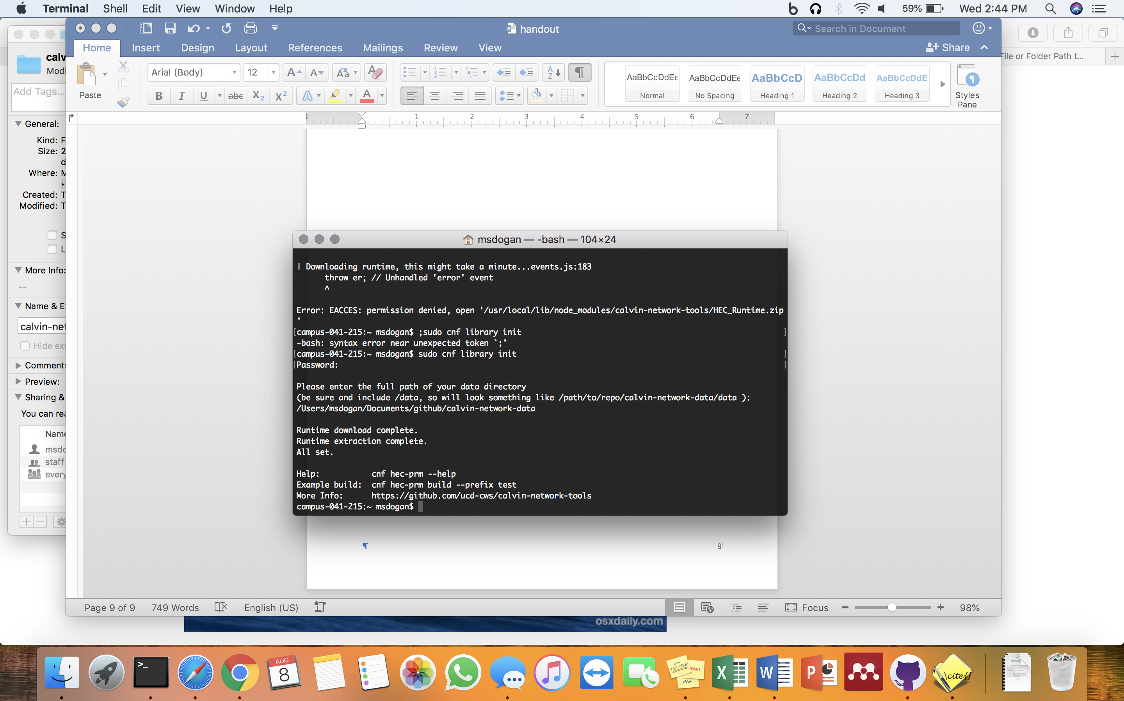

## Installing Python and other libraries via Anaconda package

We will use Anaconda, a free and open source distribution of the Python programming language for data science and machine learning related applications (large-scale data processing, predictive analytics, scientific computing), that aims to simplify package management and deployment. Anaconda distribution has several packages, including Numpy, Scipy and Pandas. If you already have Anaconda with Python 3.0+, you do not need to install again, you can proceed to Pyomo and solver installations. Otherwise, if you use Python only purposes of this course, I recommend installing miniconda with Python 3.0+ as it includes less but enough packages for this shortcourse.

Download link: <https://conda.io/miniconda.html>

## Installing Pyomo and its solver

Pyomo is a high level Python optimization modeling library. Pyomo is like a interface between your data and solver in a sense that it prepares your parameter data, decision variables, objective function, and constraints in way that solvers can understand and solve. Pyomo then gets raw results from solvers and organizes for us to Postprocess. Pyomo simply communicates between data and solvers. CALVIN can connect to several solvers but we will use GLPK, an open-source linear programming (LP) solver.

After installing miniconda v3 (or Anaconda v3), installing pyomo and GLPK solver are straightforward. We will use command line to install required packages.

conda install -c conda-forge pyomo pyomo.extras glpk

### Mac OS Pyomo and solver installation

Open Terminal (you can search for “Terminal” in your Spotlight Search if it is not in your Dock), and **type** the following command and hit **enter** to run.

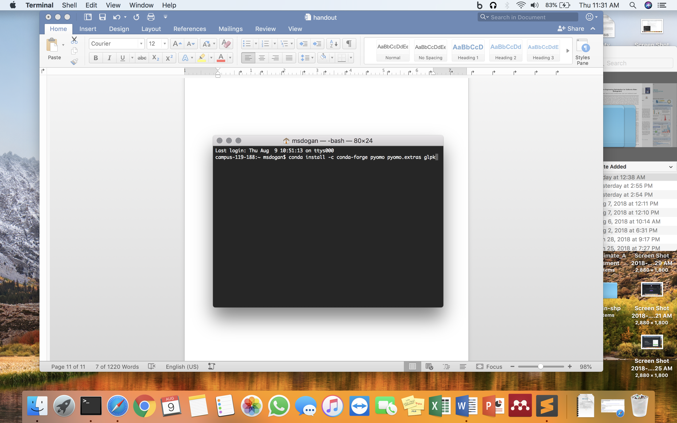

*Figure 5. Mac OS Terminal Pyomo and GLPK solver installation*

### Windows Pyomo and solver installation

You can open command line by searching “Command Prompt” in your Windows search. **Type** command above in your command line console and hit **enter** to run.

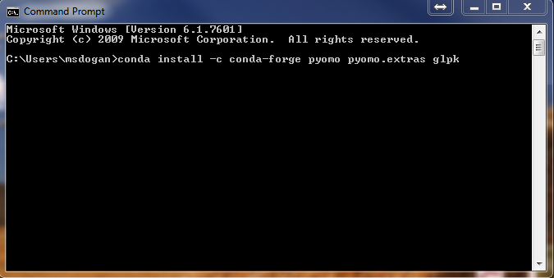

*Figure 6. Windows Command Prompt Pyomo and GLPK solver installation*

Here is a successful installation of Pyomo and GLPK solver

campus-119-188:~ msdogan$ conda install -c conda-forge pyomo pyomo.extras glpk

Solving environment: done

## Package Plan ##

environment location: /Users/msdogan/anaconda

added / updated specs:

- glpk

- pyomo

- pyomo.extras

The following packages will be downloaded:

package | build

---------------------------|-----------------

pyutilib-5.6.3 | py27_0 333 KB conda-forge

glpk-4.65 | h16a7912_1 1.0 MB conda-forge

pyomo.extras-3.3 | py27_0 3 KB conda-forge

pyomo-5.5.0 | py27_1 2.7 MB conda-forge

------------------------------------------------------------

Total: 4.1 MB

The following packages will be UPDATED:

glpk: 4.61-0 conda-forge --> 4.65-h16a7912_1 conda-forge

pyomo: 5.1.1-py27_0 conda-forge --> 5.5.0-py27_1 conda-forge

pyomo.extras: 3.2-py27_0 conda-forge --> 3.3-py27_0 conda-forge

pyutilib: 5.4.1-py27_0 conda-forge --> 5.6.3-py27_0 conda-forge

Proceed ([y]/n)? y

Downloading and Extracting Packages

Pyutilib 5.6.3: ######################################## | 100%

glpk 4.65: ############################################# | 100%

pyomo.extras 3.3: ###################################### | 100%

pyomo 5.5.0: ########################################### | 100%

Preparing transaction: done

Verifying transaction: done

Executing transaction: done

**Optional: Text editor**

If you do not have a text editor, I recommend Sublime Text <https://www.sublimetext.com> or Notepad++ <https://notepad-plus-plus.org>. Text editor can be used to open data file. With Sublime Text you can also run Python.

# CALVIN Theory and Background

Developed in early 2000s, **CAL**ifornia **V**alue **I**ntegrated **N**etwork model (CALVIN) com- bines ideas from economics and engineering optimization with advances in software and data to suggest more integrated management of water supplies regionally and through- out California. CALVIN is a hydro-economic optimization model for California’s advanced water infrastructure that integrates the operation of water facilities, resources, and demands, and it aims to optimize surface and groundwater deliveries to agricultural and urban water users. It allocates water to minimize water scarcity and operating costs (maximize statewide agricultural and urban economic value), considering physical and policy constraints. It replicates water market operations transferring water from users with lower willingness-to-pay (WTP) to users with higher WTP. CALVIN uses historical hydrology and 2050 water demand projections for its operations.

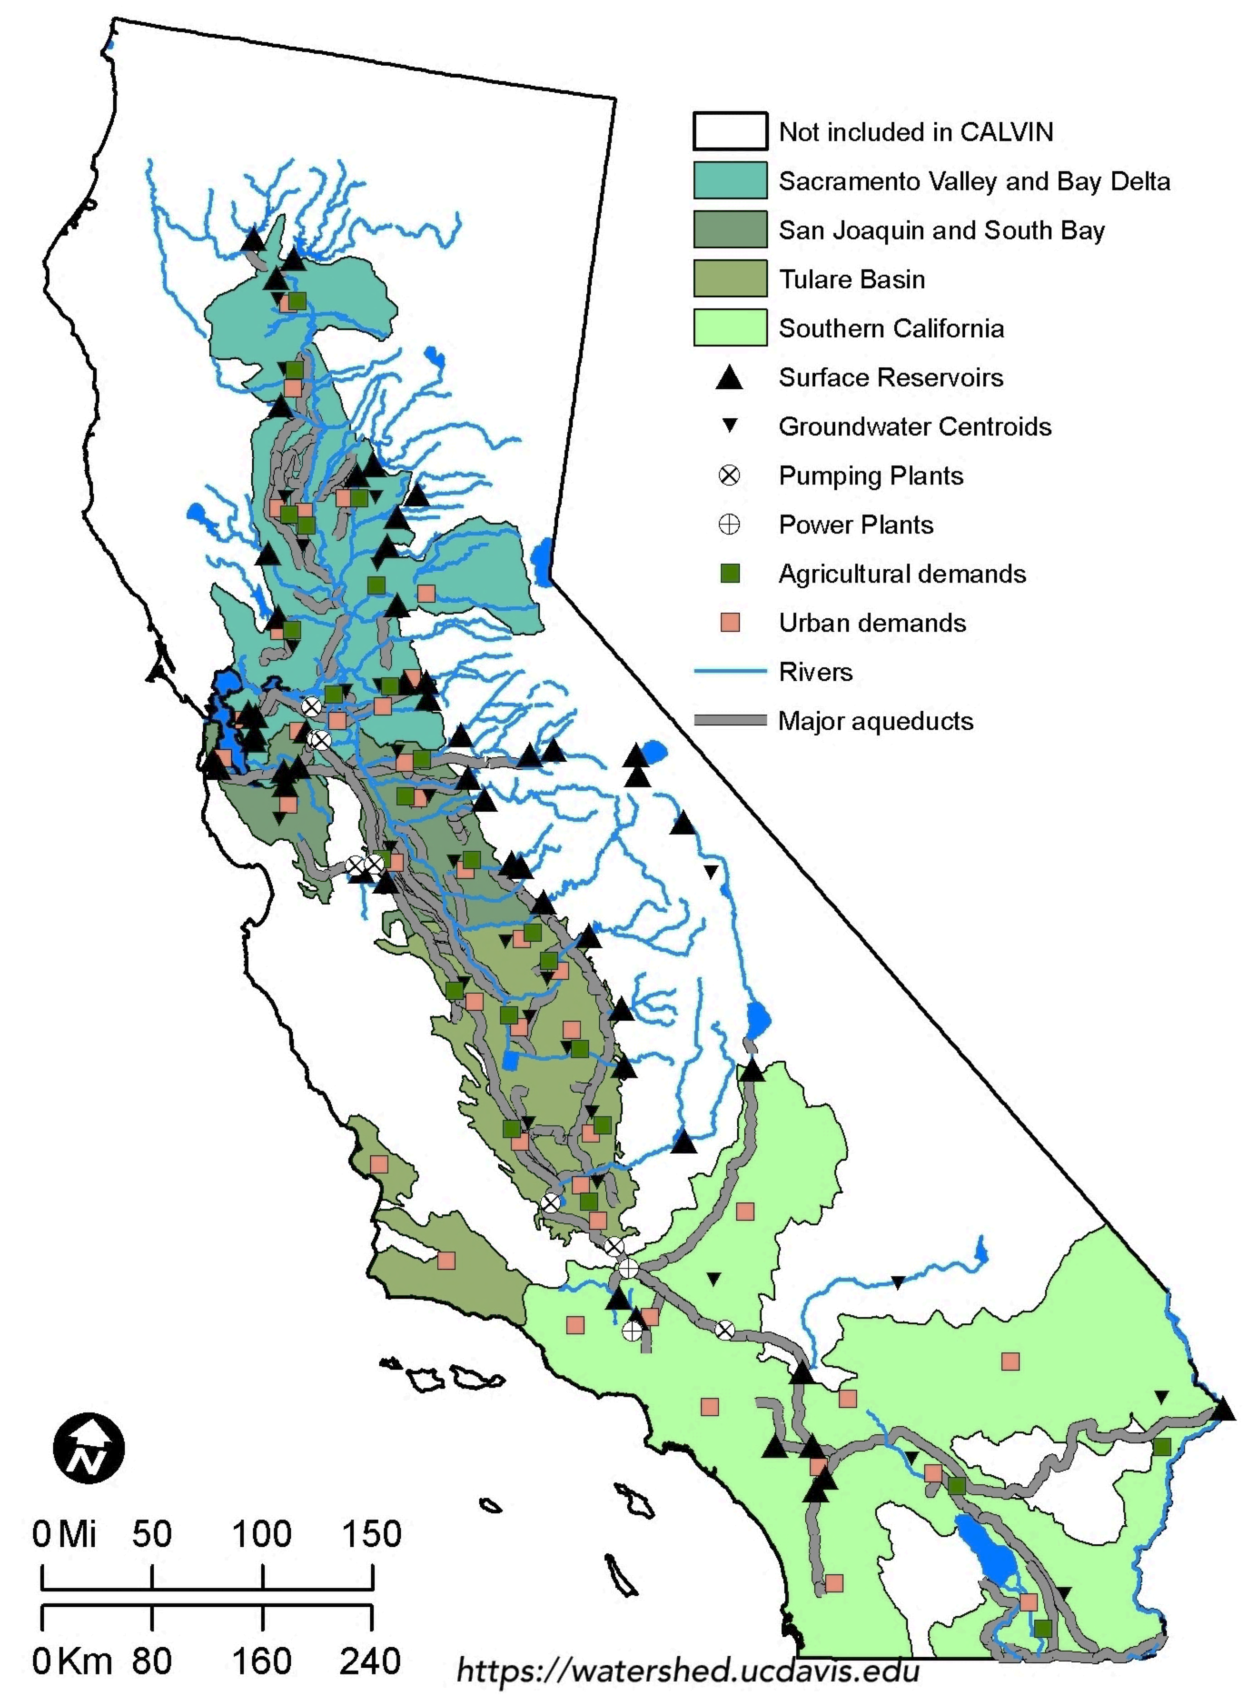

*Figure 7. California's water infrastructure and CALVIN coverage*